t

With a firm order: payment by cheque or e-transfer is required.

If goods are to be shipped from our shop {proper shipping address is important} we will notify you of the total amount including the estimated shipping cost.

Ultra Marine STRONG® Sailtrack order form

Enter your options and print and mail to:

INTERNAL SAILTRACK INFORMATION
Order Date:
Enter Comments or Instructions Below
SLIDES & FITTINGS
A - Slot Width (Letter from Disc)
B - Lip Thickness (Number from Disc)
C - Top to bottom of SailTrack groove
D - Length of existing mast gate
E - Top of mast gate to bottom of groove
Slide #
QTY
Slide # QTY
200A*
401*
200B*
402*
800A*
403*
800B*
500*
400*
600*
* Slide Type
BOAT INFORMATION
CURRENT SLIDE INFORMATION
Boat Builder
Model
Year Built
Hull I.D.
Current Slide Size (Flat) Current Slide Size (Round)
Mast Manufacturer
Mast Model
BILLING INFORMATION
OWNER INFORMATION
Customer
Boat Owner
Contact Name
Address
Address
City/Prov/Postal Code
E-Mail Address
Phone
Phone
Fax
Fax
SHIPPING INSTRUCTIONS
PAYMENT INFORMATION
Ship Track To:
Address
Ship Hardware
To Address
(If Different)
Needed By:
Shipping Method

$49.50 per foot including regular Strong track
slides, headboard slide and reef slide
$40.00 Track only.
Additional cost applies to batten receptacles

SH 200 A 1 5/8" battens $ 39.00 ea.
SH 200 B 2.00 " battens $ 43.00 ea.
Customer SailTrack
Price
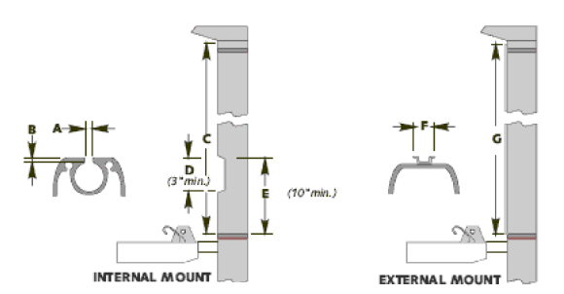
Ultra-Marine
1700-The Collegeway unit 304
Mississauga, Ontario, Canada
L5L 4M2
or Email to: heider@ultrafurl.com

EXTERNAL SAILTRACK INFORMATION
F - Width of existing external sailtrack
G - Length of existing external sailtrack

